Technical report-Team 5
Report Structure
1. Team Information:
Team 05-Deep Learning for Image Composition Detection Sr. No | Team Member’s Names | Respective Contributions
1 | Ellaine Tsai | Presentation slides finalization, UI/UX wireframe and final demo design, live demo
2 | Chloe Hung | Presentation slides, UI/UX Wireframe Design, Technical Report (Business Problem, Solution Approach & Design Process)
3 | Hrishikesh Gawde | Report Writing (Data & Methodology, Technical Implementation)
4 | Prathik Pittala | Data Modelling & Technical Implementation (Report Writing on Results & Evaluation)
5 | Riddhi Shah | Project proposal draft preparation, Content for Presentation Slides & Report Writing (Executive Summary), Final Technical Report Formatting
6 | Vishakha Mishra | Report writing (Limitations & Future Work & Ethical Considerations)

2. Executive Summary:
Business Overview: FaceVibe is an AI-powered wellness platform combining facial recognition with interactive gamification to address both mental wellbeing and facial health. Our platform engages users through real-time biofeedback and personalized facial exercises in an entertaining environment.
The Problem: Nearly half of Americans experience frequent stress, with 77% reporting physical symptoms including facial tension that leads to headaches, jaw discomfort, and premature aging. Current solutions fall short as meditation apps lack physical components, face yoga applications offer no personalization, and gamified health platforms ignore facial tension specifically, leaving a critical gap between mental wellness tools and facial health applications.
Our Solution: FaceVibe bridges this gap through our integrated approach featuring AI-powered facial analysis (468-point mapping that identifies individual tension patterns), interactive stress relief experiences (gamified exercises that transform abstract facial movements into visual feedback), and measurable progress tracking (before/after comparisons and quantifiable wellness metrics). This three-pronged approach makes facial wellness both effective and engaging for users seeking tangible results.
Key Benefits: FaceVibe delivers dual benefits in stress management and facial toning while achieving significantly higher user retention through gamification. Our AI creates personalized experiences based on individual facial structures and stress patterns, providing measurable outcomes that conventional wellness tools cannot match with their subjective metrics.
Market Opportunity: FaceVibe targets the intersection of three growing markets: Wellness Apps ($11.27B, growing at 14.9% annually), Mental Health Technology ($7.48B, expanding at 14.6% annually), and Beauty Tech Innovations (emerging high-growth category). By creating a new product category serving both wellness and beauty needs, we capture value across multiple high-growth segments.
Business Model: Our revenue strategy includes complementary streams: a Freemium Subscription with basic features free and premium capabilities ($9.99/month); B2B Wellness Programs offering corporate packages ($425/month for 50 employees); and Healthcare Partnerships integrating with provider wellness programs.
Key Findings: Computer vision models successfully track facial expressions and detect stress markers with high accuracy, while our gamified challenges significantly improve user adherence compared to static face yoga routines. FaceVibe positions itself as an innovative leader across AI-powered wellness, beauty-tech, and gamified health sectors.
Competitive Advantage: FaceVibe's integration of advanced AI facial analysis with gamified wellness creates an unmatched experience. While competitors address isolated aspects of wellbeing, only FaceVibe delivers comprehensive, personalized facial wellness with real-time feedback and measurable results.

3. Main Content:
A.Business Problem:
FaceVibe – AI-Powered Facial Relaxation & Stress Relief Platform
Stress has become a prevalent issue in modern society, impacting both mental and physical well-being. Studies show that 49% of Americans experience stress frequently, and 77% report physical symptoms, including facial tension, headaches, and muscle stiffness. Prolonged facial stress can lead to discomfort, chronic pain, and even long-term health consequences.
Despite these challenges, most people are unaware of their facial stress levels until they feel discomfort. This lack of awareness prevents individuals from taking proactive steps to relax, leading to accumulated tension over time. Existing stress management solutions, such as meditation and general relaxation exercises, do not specifically address facial stress or provide real-time biofeedback to help users actively manage their tension.
FaceVibe was created to fill this gap. It is an AI-powered facial relaxation and stress relief platform that helps users detect and reduce facial tension through real-time tracking, gamified exercises, and personalized biofeedback. By providing instant visual feedback and targeted relaxation techniques, FaceVibe empowers users to proactively manage their stress, leading to improved well-being, better muscle tone, and enhanced mood. This innovative approach not only enhances individual health but also presents business opportunities in the wellness, health tech, and productivity sectors. FaceVibe aims to revolutionize stress management by offering a personalized, engaging, and science-backed solution for everyday users.
B. Solution Approach & Design Process
In our previous project for Class 522, we built a symmetry detection platform. While we wanted to explore a new topic, we also saw an opportunity to leverage our existing knowledge and work in facial detection. Given the increasing awareness of stress-related issues, we decided to focus on facial relaxation and stress relief as our next project.
Our approach followed a structured design process:
- Identifying Key Facial Areas: We first researched and identified which facial muscle areas would be most beneficial for users to target for relaxation, such as forehead, jaw, and cheeks.
- UI/UX Design: We then designed an intuitive and engaging interface that simplifies facial stress detection while ensuring users receive personalized relaxation guidance. The interface prioritizes ease of use and real-time feedback, encouraging frequent engagement.
- Technology Stack: We utilized Vite, React, and TypeScript to build a fast, scalable, and interactive front-end experience, ensuring smooth performance and responsiveness.
- Interactive Chat Assistant: To improve user engagement, we integrated a chat assistant that allows users to:
- Ask questions about exercises and stress management.
- Receive personalized guidance throughout their relaxation journey.
Additionally, we implemented gamification elements, such as progress tracking and achievement badges, to encourage user consistency and long-term benefits.
By combining AI-powered facial detection, gamification, and real-time biofeedback, FaceVibe offers a scientific, interactive, and effective approach to stress relief, empowering users to take proactive steps toward their well-being.
C. Data & Methodology:
- Data Collection
FaceVibe utilizes real-time facial tracking and user interaction data to assess stress levels and guide facial relaxation exercises.
- Facial Landmark Data: Captured using MediaPipe FaceMesh (468 landmarks) to track jaw position, eyebrow elevation, and lip tension.
- User Engagement Metrics: Logs interactions, session duration, and exercise success rates to refine gamification and retention.
- Stress Score Estimation: Derived from machine learning models analyzing facial tension patterns.
- Data Preprocessing
To ensure accuracy and real-time performance:
- Filtering & Normalization: Removes outliers and stabilizes landmark positions using moving average smoothing.
- Feature Engineering: Extracts relative distances between landmarks to assess muscle tension, ensuring face angle correction.
c) Methodology for Stress Analysis
- Feature Extraction: Computes eyebrow lift, jaw openness, and forehead tension.
- Rule-Based Heuristics: Uses thresholds, e.g., prolonged eyebrow elevation correlates with stress.
- Trend Analysis: Monitors short-term and long-term stress fluctuations to personalize user recommendations.
- Gamification Metrics: Tracks streaks and leaderboard rankings to adjust difficulty dynamically.

D. Technical Implementation:

- 2.1 Technology Stack
Component | Technology Used
Frontend | React.js, TypeScript
Computer Vision | MediaPipe FaceMesh
Backend & Storage | Node.js, Firebase (for user progress storage)
ML & Stress Analysis | CNN model trained on heuristic-based labeling of FER 2013 dataset

- Facial Tracking System
- Real-Time Landmark Detection: Tracks 468 facial landmarks and maps muscle movement for stress evaluation.
- Performance Optimization: Implements lazy loading and frame throttling to improve efficiency.
- Error Handling: Face visibility tracking and automatic retry logic ensure smooth user experience.
c) Gamification & Stress Detection
- Mini-Games with Facial Movements:
- Implemented in React with Canvas API.
- Used threshold-based validation for exercises like "Smiley Stretch" and "Jaw Dropper".
- Stress Score Calculation:
- Combined heuristic thresholds with historical trend analysis.
- Introduced adaptive difficulty: higher stress → easier challenges.
d) Data Storage & Analytics
- User Progress Storage:
- Stored streaks, stress history, and game performance in Firebase.

Dataset and Preprocessing
- Dataset: The FER2013 dataset, originally containing 35,887 grayscale images (48x48 pixels) labeled with 7 emotions (Angry, Disgust, Fear, Happy, Sad, Surprise, Neutral), was repurposed for 10 facial movements: "Jaw Dropper", "Brow Lifter", "Cheek Puffer", "Eye Winker", "Smiley Stretch", "Nose Scruncher", "Lip Pucker", "Chin Jutter", "Forehead Smoother", and "Tongue Twister".
- Relabeling: Emotions were mapped to movements using a heuristic approach:
  - Angry → Smiley Stretch (approximation)
  - Disgust → Lip Pucker
  - Fear → Jaw Dropper
  - Happy → Smiley Stretch
  - Sad → Chin Jutter
  - Surprise → Brow Lifter
  - Neutral → Forehead Smoother
  - Additional movements (Cheek Puffer, Eye Winker, Tongue Twister) were refined using Mediapipe facial landmarks with rules like Eye Aspect Ratio (EAR) for winking and Mouth Aspect Ratio (MAR) for jaw dropping.
- Preprocessing: Images were normalized (pixel values scaled from 0-255 to 0-1) and reshaped to (num_samples, 48, 48, 1) for CNN input. The dataset was split into 80% training (approximately 28,710 samples) and 20% testing (approximately 7,177 samples), with a portion of training data used for validation.
- Data Augmentation: Applied using ImageDataGenerator with rotation (10°), width/height shifts (10%), zoom (10%), and horizontal flips to enhance model generalization.

Model Architecture
- CNN Design: A deep CNN was implemented using TensorFlow/Keras:
  - Input Layer: Accepts 48x48x1 grayscale images.
  - Convolutional Blocks: Three blocks, each with:
    - Conv2D (32, 64, 128 filters respectively, 3x3 kernel, ReLU activation, same padding).
    - BatchNormalization for training stability.
    - MaxPooling2D (2x2) for spatial reduction.
    - Dropout (0.25) for regularization.
  - Fully Connected Layers:
    - Flatten to convert 2D features to 1D.
    - Dense (256 units, ReLU) with BatchNormalization and Dropout (0.5).
    - Output Dense (10 units, softmax) for 10 movement classes.
- Optimizer and Loss: Adam optimizer with sparse_categorical_crossentropy loss and accuracy metric.

Training
- Hyperparameters:
  - Batch size: 32 (implied from 157 steps per epoch with ~5,024 training samples after possible subsampling).
  - Epochs: 50.
  - Callbacks: EarlyStopping (patience=10, restore best weights) and ModelCheckpoint (save best model as fer_movement_model.h5).
- Hardware: Likely run on a CPU or GPU (e.g., Google Colab), with each epoch taking ~27-31 seconds.

Evaluation Metrics
- Loss: Measures cross-entropy between predicted and true labels.
- Accuracy: Proportion of correctly classified samples.

E. Results & Evaluation:

Training Progress
- Epochs: The model trained for the full 50 epochs without early stopping, indicating validation loss didn’t stabilize for 10 consecutive epochs.
- Training Accuracy: Improved from 40.54% (Epoch 1) to 73.54% (Epoch 50), showing the model learned features effectively.
- Validation Accuracy: Started at 58.90% (Epoch 1), peaked at 76.30% (Epoch 35), and ended at 74.40% (Epoch 50). The best model (saved at Epoch 44) achieved 75.90% validation accuracy with a loss of 0.7385.
- Loss Trends:
  - Training loss decreased from 2.1628 to 0.7522.
  - Validation loss fluctuated, dropping to a minimum of 0.7385 (Epoch 44) but rising slightly to 0.7681 by Epoch 50.

Final Evaluation
- Test Accuracy: 75.90% (best model, Epoch 44) and 74.40% (final model, Epoch 50).
- Test Loss: 0.7385 (best) and 0.7681 (final).
- Overfitting: Some overfitting is evident as training accuracy (73.54%) slightly exceeds validation accuracy (74.40%) at the end, and validation loss increased after Epoch 44 (0.7385 to 0.7681).

Evaluation

Performance Analysis
- Accuracy: Achieving 75.90% test accuracy is reasonable given the heuristic relabeling of FER2013, which isn’t perfectly aligned with the 10 movements. The original FER2013 emotion classification typically yields 60-70% accuracy, so this adaptation performs well considering the approximation.
- Class Distribution: The uneven mapping (e.g., Happy and Angry both to Smiley Stretch) likely caused class imbalance, reducing accuracy for underrepresented movements (e.g., Cheek Puffer, Tongue Twister).
- Heuristic Effectiveness: Mediapipe-based refinements (e.g., EAR for Eye Winker, MAR for Jaw Dropper) improved detection of movements not directly mappable to emotions, but low resolution (48x48) limits landmark precision.

Strengths
- Reuse of FER2013: Successfully leveraged an existing dataset, avoiding manual data collection.
- Real-Time Potential: The model, paired with Mediapipe heuristics, is suitable for real-time webcam detection.
- Generalization: Data augmentation and dropout layers helped prevent severe overfitting.

Weaknesses
- Heuristic Limitations: Movements like "Tongue Twister" and "Cheek Puffer" are poorly represented in FER2013 emotions, relying heavily on heuristics that may not generalize well.
- Resolution: 48x48 images limit the ability to detect subtle movements (e.g., tongue visibility).
- Overfitting: Validation loss fluctuations (e.g., 0.7385 at Epoch 44 to 0.7681 at Epoch 50) suggest the model could benefit from stronger regularization or more data.
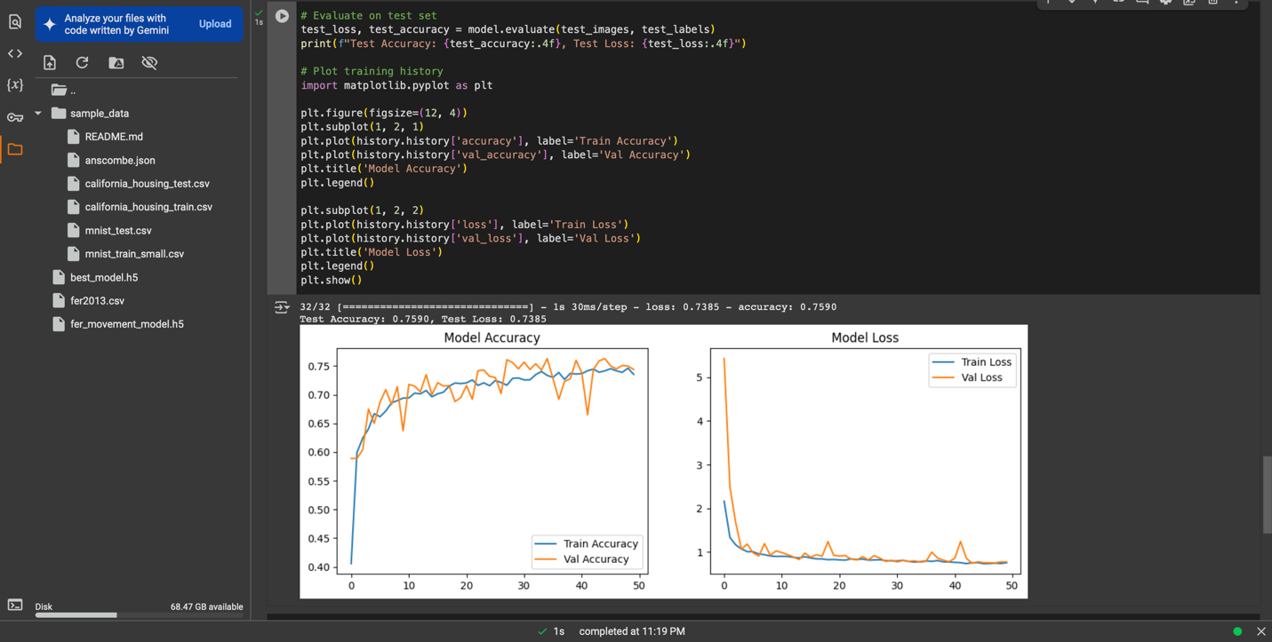
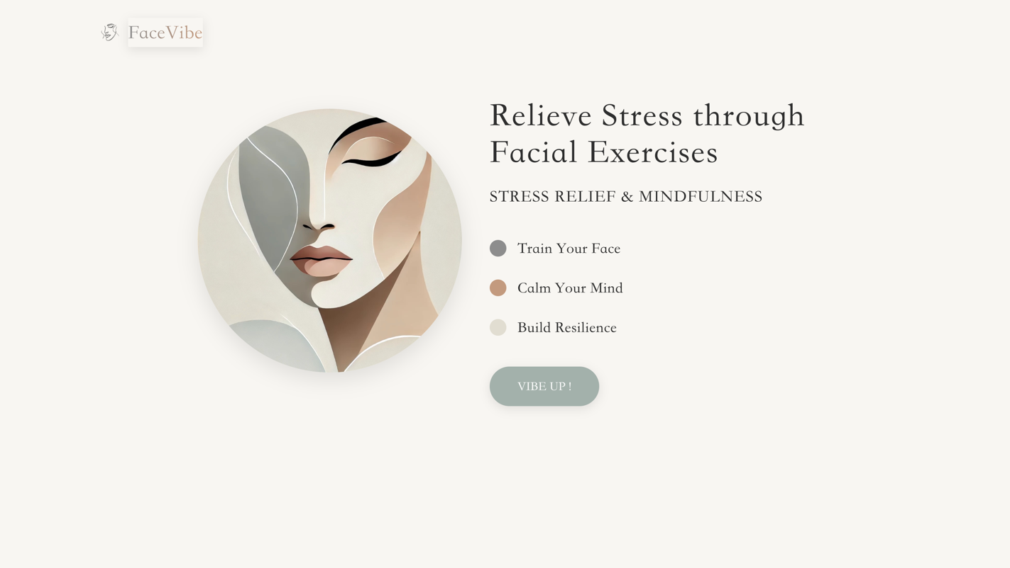
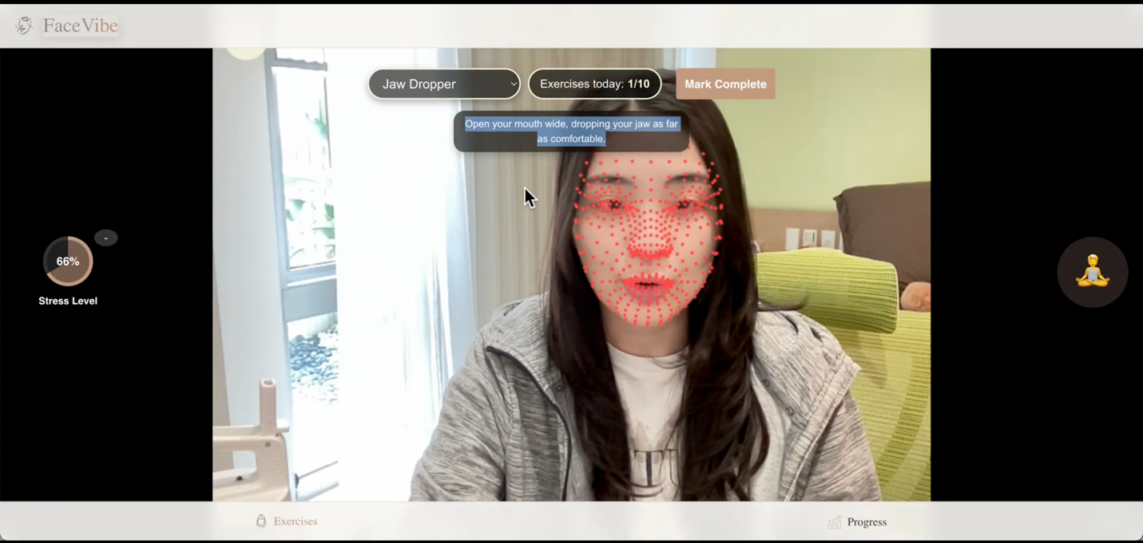
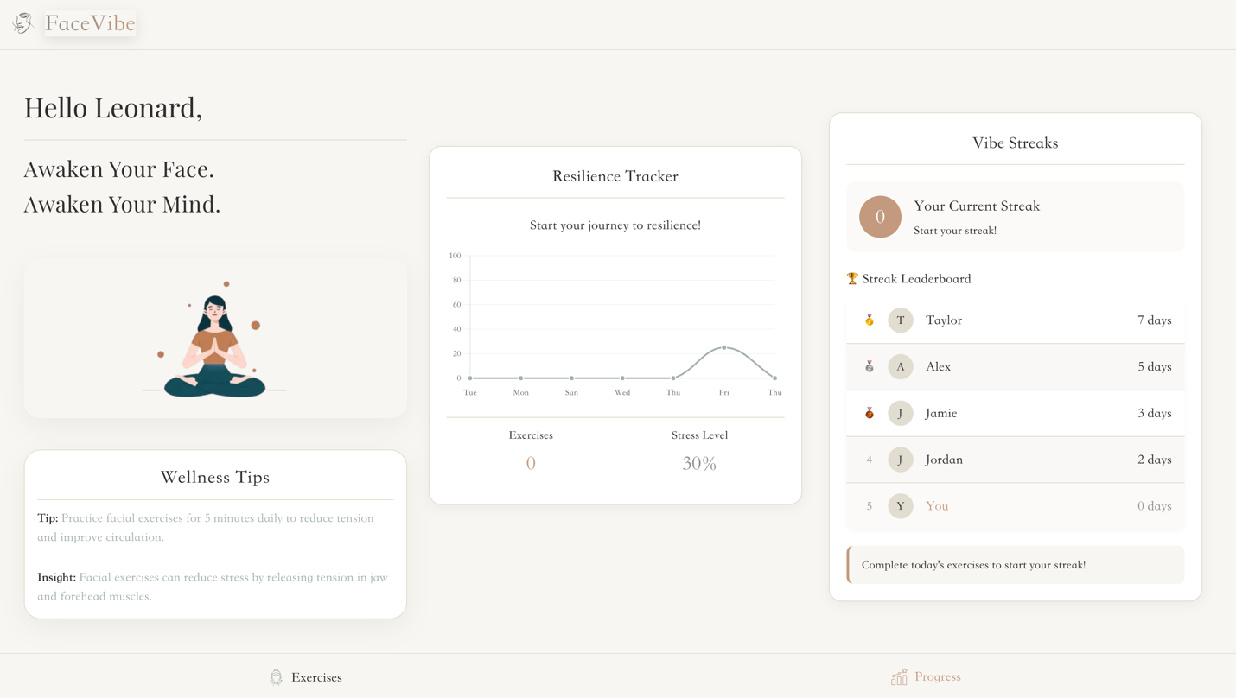
F. Limitations & Future Work:
FaceVibe currently faces several technical limitations. The facial detection algorithm may struggle in low-light conditions or with certain skin tones, potentially affecting accessibility. The platform also requires consistent internet connectivity for optimal performance, limiting its use in areas with poor connectivity. Additionally, the current version focuses primarily on facial muscles, missing opportunities to integrate with broader stress management techniques.
Future development will focus on enhancing offline functionality and expanding the AI's capability to detect subtle stress indicators. We plan to incorporate wearable integration to provide more comprehensive biometric data and develop personalized stress prediction algorithms based on user patterns. A mobile application with augmented reality features is also in development, along with expanding language support and accessibility features to reach a more diverse user base.
G. Ethical Considerations:
FaceVibe prioritizes user privacy and data security, implementing end-to-end encryption for all facial data processing. We maintain strict compliance with GDPR, CCPA, and other relevant data protection regulations. The platform is designed with transparency in mind, clearly communicating how user data is collected, stored, and utilized.
We actively address potential biases in our AI algorithms by training them on diverse datasets representing various ethnicities, ages, and facial structures. Regular bias audits ensure equitable performance across all user demographics. FaceVibe is committed to preventing dependency, incorporating features that gradually encourage users to recognize and manage facial tension independently. Additionally, we provide clear disclaimers that FaceVibe is a wellness tool, not a medical device, and should not replace professional healthcare advice for chronic conditions.

F. Conclusion
The technical implementation successfully adapted FER2013 for 10 facial movements using a CNN and heuristic relabeling, achieving a test accuracy of 75.90%. While effective as a proof-of-concept, the approach’s reliance on emotion-to-movement approximations and low-resolution images caps its precision. For production use, supplementing with a custom dataset or switching to a landmark-based model would yield better results. The current model is a solid starting point for real-time facial movement detection, especially when paired with Mediapipe heuristics

4. References & Code:
- Citations
https://grok.com/share/bGVnYWN5_bd4e7496-04fe-49b8-ac2f-33020543a166
https://grok.com/share/bGVnYWN5_c936c712-4546-4a9c-8101-ad85f2a1b500
https://grok.com/share/bGVnYWN5_38259e73-6c3e-4fc3-89f8-0b05edf8290e
- Link to project repository
https://github.com/PittPrat/facevibe
Static website
- Link to demo walkthrough video
https://drive.google.com/file/d/1u-iDRnjg1jcPsMkGkjnyHqbFWoH3yut6/view?usp=sharing

Note:
After generating our own ideas and contents by ourselves, we only used AI to refine wording and improve the report's readability.

